Rewind — Coding Standards
Oct 23, 2026 · @Ethan

How to use these standards
Every Rewind change follows these rules, and every review checks against them. They're lighter than HomeHub's on purpose: one developer, one family, and code that has to make sense in 15 years.
- Rules are MUST unless marked (SHOULD). Breaking a MUST rule is a Blocker in review; break a SHOULD rule only with a reason in the PR.
- Each rule has an ID, such as DATA-4, so review comments can cite it.
- Formatters and analyzers enforce what they can (see Tooling). If a tool's config and this doc disagree, the config wins and this doc gets updated.
- Changing a rule takes a PR to this doc; a change that affects the architecture also gets an ADR.

General principles
These apply to every language in the repo: C#, Razor, JavaScript and C.
- GEN-1 Write for the reader: clear names beat comments, and someone may read this code in 15 years.
- GEN-2 Each method does one job; prefer early returns over deep nesting.
- GEN-3 (SHOULD) Keep methods under about 30 lines and nesting to 3 levels.
- GEN-4 No magic numbers or strings: name them as constants. Prices and fees live in StoreSettings, never in code.
- GEN-5 Build only what the current phase needs; no speculative abstractions or plug-in points.
- GEN-6 No dead code, commented-out code or unused dependencies; Git keeps the old version.
- GEN-7 Movie night comes first: when an optional piece fails, such as the pole display, the NAS or the internet, Rewind says so and keeps checking out.
- GEN-8 (SHOULD) Prefer a little duplication over the wrong abstraction; extract shared code on the third use.
- GEN-9 (SHOULD) Pick boring, long-lived dependencies, and add one only when it saves real work. Every package is a 20-year commitment.

Git workflow and pull requests
Work reaches main through short-lived branches and pull requests, even when you merge your own.
- GIT-1 main always builds and passes its tests, and CI runs on every push.
- GIT-2 Branches are short-lived and named type/short-description, such as feat/shuffle-bag or fix/upc-normalize.
- GIT-3 Commit messages and PR titles follow Conventional Commits, such as feat(checkout): show change in bills and coins. Types: feat, fix, refactor, perf, test, docs, chore, ci.
- GIT-4 (SHOULD) Keep each PR to one concern and under about 400 changed lines, not counting migrations.
- GIT-5 Squash-merge, so main has one commit per change, with the PR title as its message.
- GIT-6 Never commit secrets, the database, backups, posters, logs, build output, or sound files we don't own; .gitignore covers them all.
- GIT-7 Tag a release for each phase gate and each install on the register, so the register's version always matches a tag.
- GIT-8 .gitattributes normalizes line endings to LF.

C# and .NET
Rewind targets .NET 10 and C# 14, with the compiler and analyzers catching as much as they can.
- NET-1 Nullable reference types are enabled everywhere. The null-forgiving operator (!) needs a comment saying why the value can't be null.
- NET-2 The build treats warnings as errors. Suppressing an analyzer rule needs a justification comment or an .editorconfig entry.
- NET-3 Naming: PascalCase for types, methods, properties, events, static readonly fields and constants (local ones too); camelCase for other locals and parameters; _camelCase for other private fields; an I prefix for interfaces; an Async suffix for async methods except tests, which follow TEST-6.
- NET-4 File-scoped namespaces that match the folder path, and one top-level type per file.
- NET-5 (SHOULD) Records for DTOs, commands and value objects; classes sealed unless they're designed for inheritance.
- NET-6 Async all the way: never .Result, .Wait() or GetAwaiter().GetResult(). async void is allowed only in WinForms event handlers, which catch and log their own exceptions.
- NET-7 Every async method that does I/O takes a CancellationToken and passes it along.
- NET-8 Read the time from the injected TimeProvider, never DateTime.Now or DateTime.UtcNow. Chance comes from an injected Random, so tests can seed it.
- NET-9 Money is a whole number of cents in code too, an int or a small Money record, turned into dollars only for display. Never decimal, double or float.
- NET-10 Constructor injection, with primary constructors where they fit. No service locator outside startup, and no scoped service captured by a singleton.
- NET-11 Settings that rarely change, such as folders, device USB IDs and API keys, use the Options pattern with ValidateOnStart(). Prices and fees live in StoreSettings, where the Store Manager edits them.
- NET-12 Expected outcomes, such as an unknown barcode, a case that's already out, a missing scanner or a lookup service that's offline or slow, are returned as results, not thrown. Exceptions are for the unexpected.
- NET-13 (SHOULD) Stay on .NET 10 LTS, and move to the next LTS release in its own PR after it ships.

Project boundaries
References point one way: the host knows the screens, the screens know Rewind.Core, and Core knows neither. That keeps the rules testable and leaves Windows replaceable.
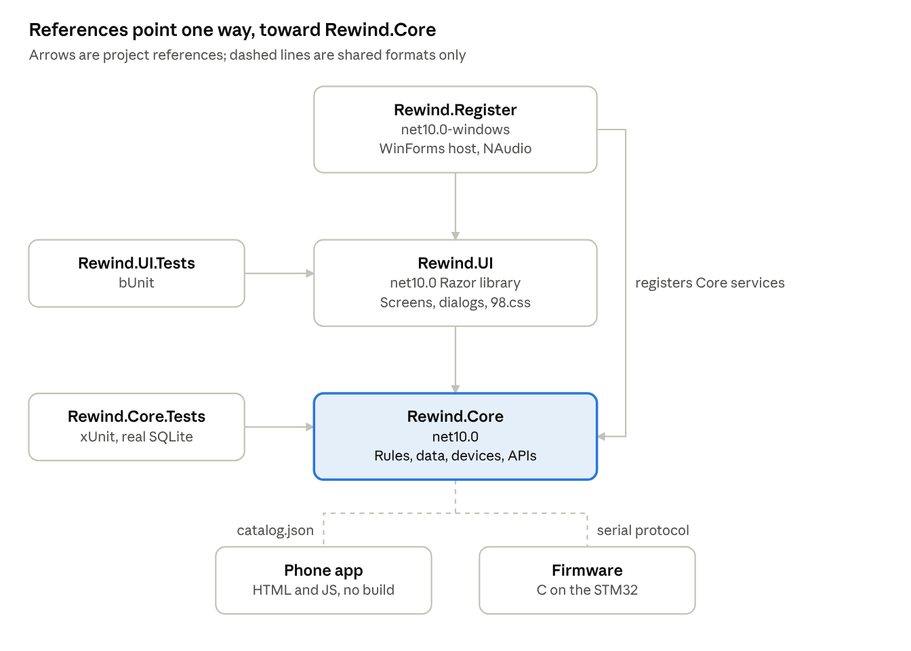
Project references · 3 projects, 2 test projects, 2 shared formats
Only Rewind.Register touches Windows, so Core and UI build and test on the Linux CI runner and could move to another host.
- ARCH-1 Rewind.Core targets net10.0 and references no UI or Windows packages: no WinForms, WebView2, NAudio or System.Management. It holds the rules, use cases, EF Core data, serial devices and HTTP clients.
- ARCH-2 Rewind.UI is a Razor class library on net10.0 that references only Rewind.Core. It never touches WinForms or Windows APIs, so it could run under Blazor Server later.
- ARCH-3 Rewind.Register targets net10.0-windows and is the only Windows-specific project: the form, BlazorWebView, the WebView2 settings, NAudio, device discovery and startup. It holds no business logic.
- ARCH-4 Core defines the interfaces the host implements, such as ISoundPlayer and IDeviceLocator.
- ARCH-5 A component calls one Core service per user action and renders its result. Components never query EF Core directly. No MVVM framework: a component's own fields hold its UI state, and a screen that outgrows them moves that state into a plain C# class in Rewind.UI (ADR-0003).
- ARCH-6 (SHOULD) Organize Core by feature (Checkout, Returns, Intake, Shelves, CloseOut, Devices, Metadata), not by technical type.
- ARCH-7 (SHOULD) An architecture test (NetArchTest) fails the build if Core or UI references anything Windows-specific.
- ARCH-8 The phone app and the firmware share no code with .NET, only contracts: catalog.json's shape and the serial protocol. Both are documented and carry a version.

Blazor and 98.css UI
The register should feel like 1998 and work like a real counter: keyboard first, scans from anywhere, and errors that never strand the clerk.
- UI-1 Style with 98.css classes plus one site.css of layout rules; no other CSS frameworks, icon fonts or Bootstrap from the templates.
- UI-2 Stay in 1998: no rounded corners, shadows, gradients or transitions beyond what 98.css draws. The only animations are the spinner and the overdue flash.
- UI-3 Every screen works by keyboard alone. F1 to F5 switch screens, Enter presses the focused button (a dialog opens with OK focused), Esc cancels, Tab follows the visual order, and nothing needs hover.
- UI-4 Scans never depend on focus: screens receive them from the scanner service, never from a text box.
- UI-5 Dialogs are 98.css windows shown by one DialogService. Never alert(), confirm() or a native MessageBox.
- UI-6 Every view handles loading, empty and error states. Each screen sits in an ErrorBoundary that shows a Windows 98 error dialog and returns to Checkout, unless Checkout is what crashed.
- UI-7 Sounds are named events (Scan, Chime, Error, Drop, Tick) played through ISoundPlayer; components never refer to sound files.
- UI-8 Design for 1024×768 CSS pixels and check it at whole-number WebView2 zoom levels. The total and the change due use large text a customer can read.
- UI-9 JavaScript lives in one small module for keyboard, focus and printing. No JavaScript frameworks and no inline event handlers.
- UI-10 Text from TMDB or UPCitemdb renders as text, never as MarkupString.
- UI-11 Background events, such as scans and drops, reach components only through InvokeAsync, never straight from a serial thread, and a handler's exception goes to DispatchExceptionAsync so the screen's ErrorBoundary catches it.

Data and EF Core
The SQLite file is the heirloom, so every rule here protects what's in it.
- DATA-1 One database, C:\Rewind\data\rewind.db, in WAL mode, opened with Foreign Keys=True in the connection string. That keyword sets the pragma right after each connection opens, where it can't be swallowed by a transaction.
- DATA-2 Money is whole cents in INTEGER columns, never decimal or REAL. EF Core can't compare or sort decimals inside SQLite.
- DATA-3 Unknown is NULL, never 0, an empty string or "NR". Filters say what they do with NULL.
- DATA-4 History is never deleted. Cases retire, members and concession items deactivate, and every foreign key is DeleteBehavior.Restrict, set once in OnModelCreating, because EF Core cascades required relationships by default.
- DATA-5 Schema changes happen only through EF Core migrations. Read each migration's SQL, including any SQLite table rebuild, and never edit a migration that has run on the register. Rewind backs up before it applies one.
- DATA-6 Get contexts from IDbContextFactory and dispose them after each operation. Never hold a DbContext in a component or a singleton.
- DATA-7 A user action that writes several rows, such as a checkout, a return or an intake, saves them in one SaveChanges or one explicit transaction.
- DATA-8 Instants are stored as UTC DateTime values and shown in local time. EF Core reads them back as Unspecified, so a converter marks them UTC. Movie-night logic uses BusinessDays, never calendar dates.
- DATA-9 TMDB data lives only in Movies, MovieCast and MovieGenres, and a refresh writes only there. Family data lives in its own tables.
- DATA-10 Prices are copied onto RentalItems and SaleLines at the time of sale.
- DATA-11 Rules the database can hold, it holds: unique labels and cards, one draw per member per business day, one open business day, stars between 1 and 5, and a rental item's case and movie pair in CaseMovies.
- DATA-12 Read queries use AsNoTracking and project to records with Select; lazy loading stays off.
- DATA-13 No SQL built by string concatenation; raw SQL uses parameters.
- DATA-14 Never copy rewind.db while Rewind runs. Backups go through SQLite's backup API to a new, timestamped file.

Counter hardware and firmware
The devices are the part most likely to be unplugged, bumped or replaced, so both sides of every cable assume the other one can vanish.
- HW-1 Every device speaks the line protocol from the Overview: ASCII at 115200 8N1, one message per line, fields split by a pipe. New messages may be added; existing ones never change meaning.
- HW-2 The register finds devices by USB vendor and product ID, never by a saved COM number.
- HW-3 Serial reads run on a background task and raise events; nothing blocks the UI thread.
- HW-4 Unplugging any device never crashes Rewind. The status bar shows it, Rewind retries every few seconds, and checkout carries on.
- HW-5 Both sides tolerate the unknown: the firmware answers ERR|UNKNOWN, and the register logs and ignores what it doesn't know.
- HW-6 The register formats everything for the pole display: plain ASCII, each line padded or trimmed to the display's width. The firmware only prints.
- HW-7 Interrupt handlers only record a time or set a flag. Debouncing, I2C and serial writes happen in the main loop, and HAL_Delay never runs in an interrupt.
- HW-8 UART receive restarts after any error, so an overrun can't silence the board.
- HW-9 The firmware's line parser is plain C with no HAL calls, so it compiles and runs its tests on the desktop.
- HW-10 The firmware sends READY with its version at boot and answers PING with PONG. Help > About shows the firmware version.
- HW-11 (SHOULD) Pin choices live in the CubeMX .ioc file and one pins.h, and wiring changes go in the firmware README.

Security and privacy
Rewind holds the family's names and history, talks to two web APIs and copies files to the NAS, so these rules apply from the first commit.
- SEC-1 No secrets in the repo. Development uses dotnet user-secrets; the register keeps the TMDB token and the NAS key under C:\Rewind\keys, readable only by the Counter account.
- SEC-2 The phone catalog holds movies only: no member names, prices or watch history.
- SEC-3 The NAS account is SFTP-only and locked into its own folder, with no shell. Backups and the catalog land in separate folders, and only the catalog folder is served.
- SEC-4 Rewind checks the NAS host key's fingerprint before every upload.
- SEC-5 Treat API answers and barcodes as untrusted: validate them, cap their length, and build poster file names from TMDB IDs, never from titles.
- SEC-6 WebView2 shows only Rewind's own pages. Outside links are cancelled, and dev tools, the right-click menu, browser shortcuts and autofill are off in Release builds.
- SEC-7 Logs never contain tokens, keys or passwords.
- SEC-8 Dependabot watches NuGet and GitHub Actions, and NuGetAuditLevel is high, so a high or critical advisory fails the build until it's fixed.
- SEC-9 The register signs in as a standard account, never an administrator.

Testing
Tests prove behavior, run on every push, and never depend on the clock, luck or real hardware.
- TEST-1 Every bug fix includes a test that fails without the fix.
- TEST-2 New rules ship with tests in the same PR: money and change, the shuffle bag, barcode types, business days, spinner filters and the Close Out steps.
- TEST-3 Data tests run against a real SQLite database with migrations applied, never the EF Core in-memory provider.
- TEST-4 Time and chance are faked: FakeTimeProvider for time, and a seeded Random for the shuffle bag and the spinner. Tests never sleep or depend on today's date.
- TEST-5 Devices sit behind interfaces with fakes, and a Debug-only simulator lets you type scans and trigger drops without any hardware.
- TEST-6 Test names describe behavior as Method_Scenario_ExpectedResult, such as Draw_AfterBagEndsOnOverdue_NeverStartsWithOverdue.
- TEST-7 Each test follows Arrange, Act, Assert and checks one behavior. Tests are independent and can run in any order.
- TEST-8 Key screens have bUnit tests, and the firmware's line parser has plain C tests that run in CI.
- TEST-9 Before each release to the register, run the movie-night checklist on the real counter.

Errors, logging and diagnostics
When something goes wrong on movie night, the clerk sees a friendly Windows 98 dialog and the log keeps the details for later.
- OBS-1 Log with message templates, such as logger.LogInformation("Case {Label} checked out", label), never with string interpolation.
- OBS-2 Logs go to rolling files in C:\Rewind\logs through Serilog, kept for 30 days.
- OBS-3 Log levels: Error needs attention, Warning is a handled problem, Information marks key events such as checkouts, returns and Close Outs, and Debug is detail for troubleshooting.
- OBS-4 Never swallow an exception. Catch only what you can handle, and log it once, where it's handled.
- OBS-5 Unhandled exceptions are caught in four places. Each screen's ErrorBoundary, the ErrorBoundary around the whole shell and Application.ThreadException log, show the Windows 98 error dialog and return to Checkout, unless Checkout is what crashed: it then stays closed until the clerk presses an F-key. AppDomain.UnhandledException can only log: the process then ends, and the launcher restarts Rewind. Recovery never reopens what just crashed on its own, so a shell that crashes before it has started shuts Rewind down.
- OBS-6 The status bar shows the health of everything optional: scanner, pole display, return box, internet, last backup and last NAS copy.

Documentation
Write down the why and the how-to-recover; the code already shows the what.
- DOC-1 Each significant decision gets a numbered ADR in docs/adr with context, decision, alternatives and consequences. An accepted ADR is never rewritten; a new one supersedes it.
- DOC-2 Comments explain why, not what.
- DOC-3 Public Core services have XML doc comments.
- DOC-4 The README explains what Rewind is, how to run it with the hardware simulator, how to test, how to release to the register and how to restore a backup. Update it in the same PR as any change to those.
- DOC-5 Every TODO links an issue, such as TODO(#12); no anonymous TODOs.
- DOC-6 The clerk handbook in docs/handbook is one printable page, written for the kids, and changes whenever a screen does.
- DOC-7 The serial protocol and catalog.json's format are documented next to their code, with an example of every message.

Tooling and enforcement
Tools enforce formatting and most rules, so reviews can focus on correctness and the look.
Directory.Build.props at the repo root applies to every .NET project:
<Project>
<PropertyGroup>
<Nullable>enable</Nullable>
<ImplicitUsings>enable</ImplicitUsings>
<TreatWarningsAsErrors>true</TreatWarningsAsErrors>
<AnalysisLevel>latest-recommended</AnalysisLevel>
<EnforceCodeStyleInBuild>true</EnforceCodeStyleInBuild>
<NuGetAuditLevel>high</NuGetAuditLevel>
</PropertyGroup>
<ItemGroup>
<AdditionalFiles Include="$(MSBuildThisFileDirectory)BannedSymbols.txt" />
</ItemGroup>
</Project>
Rewind.Register's project file adds the Windows pieces, and EnableWindowsTargeting lets the Linux CI runner build it:
<Project Sdk="Microsoft.NET.Sdk.Razor">
<PropertyGroup>
<OutputType>WinExe</OutputType>
<TargetFramework>net10.0-windows</TargetFramework>
<UseWindowsForms>true</UseWindowsForms>
<EnableWindowsTargeting>true</EnableWindowsTargeting>
</PropertyGroup>
</Project>
- Package versions live in one Directory.Packages.props (Central Package Management).
- .editorconfig holds the C# naming and style rules, and CI runs dotnet format --verify-no-changes.
- BannedSymbols.txt lists the APIs that NET-6 and NET-8 forbid, such as DateTime.Now and Task.Result, and the BannedApiAnalyzers package fails the build wherever one is used.
- The phone app has no build step. A package.json containing only "type": "module" lets node --check parse its ES modules in CI.
- (SHOULD) The firmware builds in STM32CubeIDE with -Wall -Wextra and no warnings.
CI gates on every push and pull request; all must pass to merge:
- Build with zero warnings, plus the format check.
- Core and UI tests: xUnit and bUnit.
- The firmware parser's C tests, built and run with gcc.
- node --check on the phone app's JavaScript.
- NuGet audit: restore fails on a high or critical advisory.
- Pull request title: a Conventional Commit, since squash-merging makes it main's commit message (GIT-3, GIT-5).
Releases are built on the Windows desktop with dotnet publish src/Rewind.Register -c Release -r win-x64 --self-contained, zipped, and attached to the matching GitHub release before going on the register.

Code reviews
Every PR is reviewed against this doc before it merges, and each finding names its severity and the rule it cites.
Severity | Meaning | Before merge
Blocker | A bug, security hole, data-loss risk or broken MUST rule | Must be fixed
Should fix | A broken SHOULD rule or a clear maintainability problem | Fix now, or open an issue and link it
Nit | Small polish the tools don't catch | Optional
Praise | Something done well that's worth repeating | Nothing to do
Review checklist, in priority order:
- Correctness: it does what the PR says, including money, time zones, business days and empty states.
- Data safety: nothing is hard-deleted, foreign keys stay Restrict, the migration's SQL was read, and prices are copied at the time of sale.
- Movie night: a missing device, network or NAS shows a message instead of stopping checkout.
- Security: no secrets in the repo, untrusted input validated, WebView2 still locked down.
- Tests: new rules and bug fixes are covered, and the tests would fail if the code broke.
- Architecture: references follow the ARCH rules, and logic lives in Core.
- The look: 98.css only, the keyboard works, and nothing modern sneaks in.
- Readability: names, size and structure, with comments that explain why.
- Docs: README, handbook or ADR updated when setup or a decision changes.
Asking Claude for a review: paste the PR description and the diff (git diff main...HEAD) or the changed files. The review comes back grouped by severity, with each finding citing a rule ID.
PR template (.github/pull_request_template.md):
## What changed
## Why
## How it was tested
## Links (issue or ADR)
- [ ] Builds with zero warnings; format passes
- [ ] Tests added or updated and passing
- [ ] README, handbook or ADR updated if setup or a decision changed
- [ ] Tried on the counter or the simulator (UI or hardware changes only)
Definition of Done: the PR is merged with every Blocker resolved and CI green, the change is released to the register or queued for the next release, and UI or hardware changes have been tried on the real counter.

